**Amazon Advertising Campaign Performance Analysis**

# **Overview**

This report analyzes the performance of Amazon Advertising campaigns. The objective is to identify high-performing and underperforming campaigns based on key performance metrics such as Click-Through Rate (CTR), Cost-Per-Click (CPC), Advertising Cost of Sales (ACoS), Return on Advertising Spend (ROAS), and Conversion Rate. The report also provides insights into campaign type and targeting strategy effectiveness, followed by actionable recommendations for optimization.

# **Key Performance Indicators used.**

* **Click-Through Rate (CTR)** = (Total Clicks / Total Impressions) × 100

(Measures how engaging the ad is by showing the percentage of people who clicked on it after seeing it. A higher CTR indicates that the ad is relevant to the audience.)

* **Cost-Per-Click (CPC)** = Total Spend / Total Clicks

(Represents the average amount paid for each click on the ad. A lower CPC means more cost-efficient traffic.)

* **Advertising Cost of Sales (ACoS)** = (Total Spend / Total Sales) × 100

(Shows the percentage of revenue spent on advertising. A lower ACoS means better ad efficiency.)

* **Return on Advertising Spend (ROAS)** = Total Sales / Total Spend

(Indicates how much revenue is generated for every dollar spent on advertising. A higher ROAS means better profitability.)

* **Conversion Rate** = (Total Orders / Total Clicks) × 100

(Measures how effective the ad is in driving purchases by showing the percentage of clicks that result in sales. A higher conversion rate means the ad is attracting the right audience.)

# **Campaign Perform Analysis**

## **Overall CTR, CPC, ACoS, ROAS and Conversion Rate across all campaigns**



*Note-For detailed metrics, please refer to the attached Excel sheet.*

Analysis of the same in Power BI is as shown below. You ca.n find the interactive dashboard in the pbix file attached

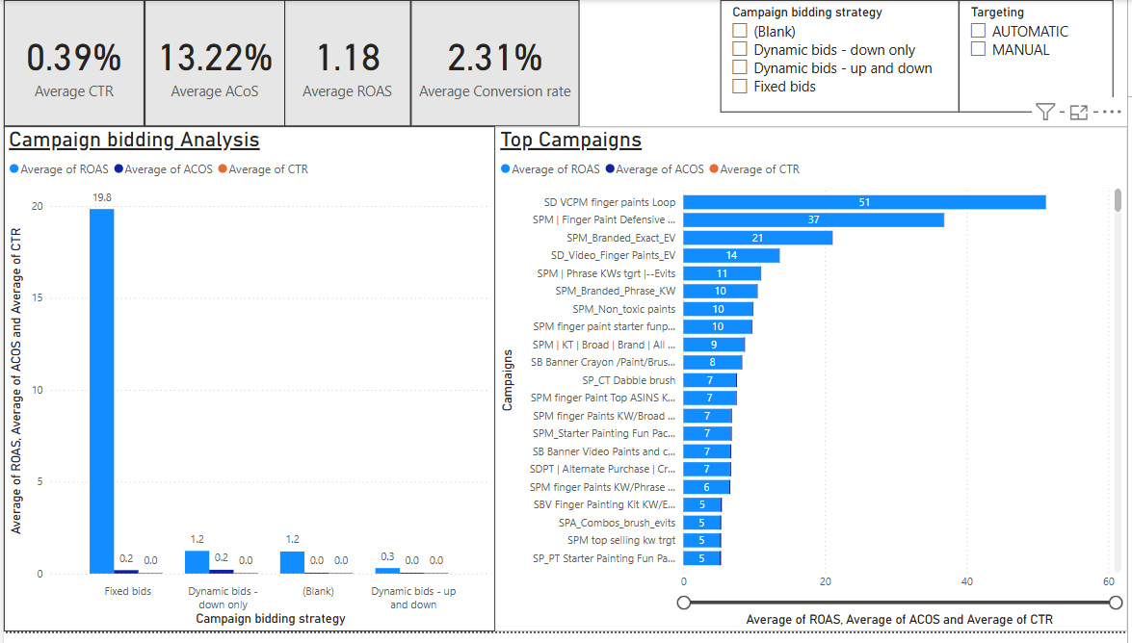

*You can access the dashboard through this* [*link*](https://app.powerbi.com/groups/me/reports/32d9030a-1894-44e3-a0ff-3e6d060c0dd4/4060b8ffe76b5706c2cb?experience=power-bi) *or can use the pbix file attached.*

*Note-For detailed metrics, please refer to the attached pbix file.*

## **Top 5 Campaigns with the Highest ROAS**

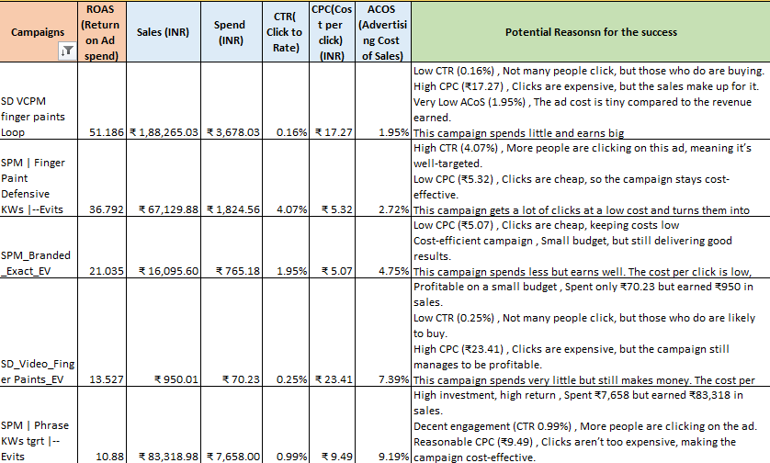

*Note-For detailed metrics, please refer to the attached Excel sheet.*

## **Bottom 5 Campaigns in terms of ACoS**

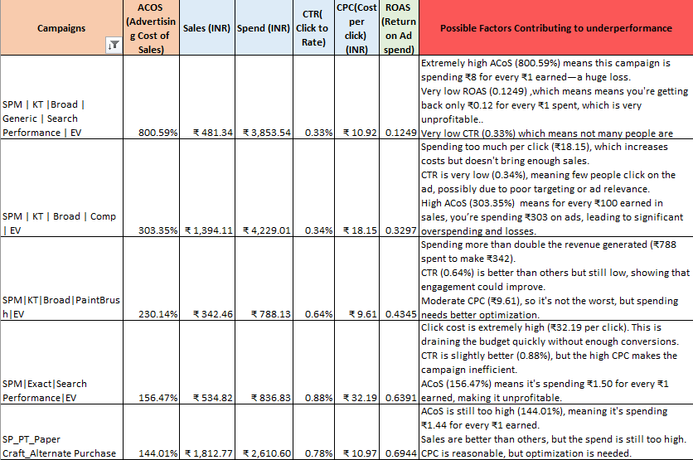

*Note-For detailed metrics, please refer to the attached Excel sheet.*

# **Campaign Type Evaluation**

## **Performance metrics across different bidding strategy**

|  |  |  |  |  |
| --- | --- | --- | --- | --- |
| **Performance metrics across different bidding strategy** | | | | |
| **Row Labels** | **CTR** | **ACOS** | **ROAS** | **Conversion Rate** |
| **MANUAL** | **0.46%** | **13.39%** | **1.29** | **2.62%** |
| Dynamic bids - down only | 0.36% | 23.04% | 1.39 | 2.49% |
| Dynamic bids - up and down | 0.20% | 5.12% | 0.36 | 0.69% |
| Fixed bids | 2.23% | 18.74% | 19.83 | 17.03% |
| (blank) | 0.68% | 3.68% | 1.20 | 3.46% |
| **AUTOMATIC** | **0.08%** | **12.41%** | **0.69** | **0.86%** |
| Dynamic bids - down only | 0.09% | 14.69% | 0.82 | 1.01% |
| Dynamic bids - up and down | 0.00% | 0.00% | 0.00 | 0.00% |
| **Grand Total** | **0.39%** | **13.22%** | **1.18** | **2.31%** |

*Note-For detailed metrics, please refer to the attached Excel sheet.*

**Analysis of the Table:**

* Manual campaigns achieved a significantly higher CTR, indicating better targeting and more relevant ads.
* Automatic campaigns showed slightly better ACoS, suggesting they were somewhat more cost-efficient in terms of spend versus revenue.
* Manual campaigns delivered a stronger ROAS, meaning they generated more revenue for every ₹1 spent on advertising.
* Manual campaigns also had a higher conversion rate, indicating that a greater percentage of users who clicked on the ad completed a purchase.

**Manual campaigns outperformed** overall due to:

* Higher CTR (indicating better engagement)
* Higher ROAS (resulting in better returns)
* Higher Conversion Rate (leading to more sales)

A possible reason for this is that manual campaigns provide greater control over targeting and keyword selection. In contrast, automatic campaigns depend on algorithms, which may not always optimize ad placements effectively.

**Best Performing Bidding Strategy:**  
**Fixed Bids** delivered the strongest performance, achieving:

* The highest CTR (indicating greater engagement)
* The highest ROAS (resulting in better returns)
* The highest Conversion Rate (leading to more sales)

## **Performance metrics across different Campaign type**

|  |  |  |  |  |
| --- | --- | --- | --- | --- |
| **Performance metrics across different Campaign type** | | | | |
| **Row Labels** | **CTR** | **ACOS** | **ROAS** | **Conversion Rate** |
| **MANUAL** | **0.46%** | **13.39%** | **1.287265934** | **2.62%** |
| SD VCPM finger paints Loop | 0.16% | 1.95% | 51.1864 | 151.17% |
| SPM | Finger Paint Defensive KWs |--Evits | 4.07% | 2.72% | 36.7924 | 27.41% |
| SPM_Branded_Exact_EV | 1.95% | 4.75% | 21.0351 | 19.87% |
| SD_Video_Finger Paints_EV | 0.25% | 7.39% | 13.5271 | 66.67% |

*Note-For detailed metrics, please refer to the attached Excel sheet.*

**SD VCPM finger paints Loop** performs best in cost-efficiency (ACOS), revenue generation (ROAS), and conversion rate. While its CTR is low (0.16%), it excels at converting the few clicks it gets into actual sales, making it the most effective in terms of profitability.

**Possible Reasons for High Performance:**

* **Targeting the Right Customers:**  
  Even with a lower CTR, the clicks came from genuinely interested shoppers, leading to a high conversion rate.
* **Effective Ad Messaging:**  
  A compelling ad copy, attractive visuals, or a strong offer helped attract serious buyers instead of casual browsers.
* **Optimized Ad Spend:**  
  The campaign focused on high-value keywords and the right audience, reducing wasteful spending and maximizing profitability.
* **Manual Targeting for Precision:**  
  Instead of relying on automation, manual targeting ensured ads reached the most relevant shoppers through specific keywords, audiences, or placements.
* **Seamless Shopping Experience:**  
  A well-optimized landing page with clear product details and a smooth checkout process encouraged more conversions.

# **Targeting Type Analysis**

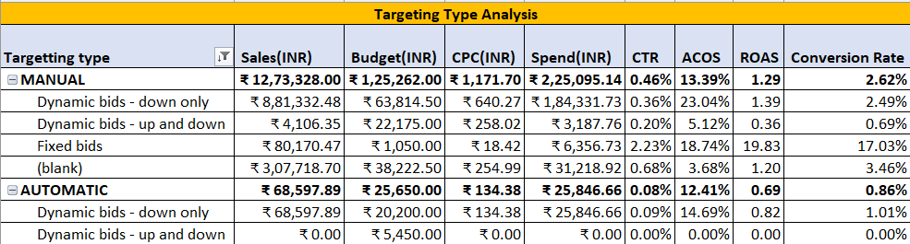

*Note-For detailed metrics, please refer to the attached Excel sheet.*

**Performance Comparison: Manual vs. Automatic Targeting**

* **Higher Sales:**  
  Manual targeting generated approximately 18.5 times more sales compared to automatic targeting.
* **Higher Conversion Rate:**  
  With manual targeting, ads reached more qualified shoppers, increasing the likelihood of purchases.
* **Better Return on Ad Spend (ROAS):**  
  Every ₹1 spent on manual targeting resulted in ₹1.29 in revenue, making it more profitable than automatic targeting.
* **Improved Click-Through Rate (CTR):**  
  A higher CTR indicates that manually targeted ads were more relevant and engaging to shoppers.
* **Ad Cost Efficiency (ACoS - Advertising Cost of Sales):**  
  While ACoS was slightly higher for manual campaigns, the increase in sales, conversion rate, and ROAS made it a more cost-effective approach.

**Potential Reasons for Better Performance Metrics**

* **Reaching the Right Customers:**  
  Manual targeting ensures ads are displayed to high-intent shoppers rather than random users, leading to better conversions.
* **Optimized Keyword Selection:**  
  Advertisers can choose high-performing keywords, attracting more relevant traffic and increasing sales.
* **Efficient Budget Allocation:**  
  Funds are allocated to top-performing keywords and campaigns, minimizing waste on low-performing ads.
* **Higher Engagement Through Well-Optimized Ads:**  
  Strategically placed and optimized ads capture attention, resulting in higher click-through rates and engagement.
* **Better Cost Control:**  
  Manual bidding allows advertisers to set optimal cost-per-click (CPC), maximizing performance without overspending.

**Actionable Recommendations to Improve Amazon Advertising Campaigns**

**1. Allocate Budget to High-Performing Strategies**

* Increase spending on "Dynamic Bids – Down Only" in Manual Targeting, as it generated the highest sales (₹8.8L) and delivered strong performance.
* Reduce investment in "Dynamic Bids – Up and Down", which had lower returns and underperformed.

**2. Utilize Fixed Bids for Better Conversions**

* Fixed Bids achieved the highest conversion rate (17.03%) and the best return on ad spend (ROAS), meaning users who clicked were more likely to purchase.
* Increasing the budget for Fixed Bids can help maximize sales while maintaining cost efficiency.

**3. Leverage Automatic Targeting for Keyword Discovery**

* While Automatic Ads did not perform well overall, they can be useful for identifying high-performing keywords.
* Transfer successful keywords from automatic campaigns to manual targeting to gain better control over bidding and costs.

**4. Optimize Bidding Strategy for Profitability**

* Lower bids on "Dynamic Bids – Down Only" to reduce cost-per-click (CPC) while maintaining good results.
* Implement negative keywords to prevent ads from appearing in irrelevant searches, ensuring ad spend is focused on high-intent buyers.

# **Recommendations**

**Actionable Strategies to Improve Advertising Performance**

**1. Reallocate Budget from Low-ROAS to High-ROAS Campaigns**

**Objective:** Maximize revenue by shifting ad spend to more profitable campaigns.

**Action Plan:**

* Reduce the budget for campaigns with ROAS < 1.5 and ACoS > 40% as they generate low returns.
* Increase the budget for high-performing campaigns with ROAS > 3.0 and ACoS < 30% to optimize profitability.
* Conduct weekly performance reviews to ensure efficient budget allocation

**2. Optimize Keywords & Targeting for Low-CTR Campaigns**

**Objective:** Improve engagement and ad visibility by refining keyword and audience targeting.

**Action Plan:**

* **For Manual Targeting:**
  + Analyze keyword performance and pause high-spend keywords with low CTR (<0.3%) and low conversions.
  + Increase bids on high-converting keywords to boost visibility.
  + Implement negative keywords to minimize irrelevant clicks and reduce wasted ad spend.
* **For Automatic Targeting:**
  + Refine ASIN targeting by focusing on high-converting competitor products instead of broad targeting.

**3. Adjust Bidding Strategy to Improve CPC & ACoS**

**Objective:** Optimize bid strategies to balance cost efficiency and ad visibility.

**Action Plan:**

* Lower bids on high CPC keywords that have low conversion rates to improve cost efficiency.
* Implement Dynamic Bidding – Down Only to reduce ad spend on underperforming placements.
* Test Product Placement Adjustments (Top of Search vs. Rest of Search vs. Product Pages) to identify the most cost-effective placements for better returns.